**Programming – Bat Race Macintosh HD:Users:richardlam:Desktop:Screen Shot 2015-05-17 at 1.56.33 PM.png**

**Create a bat-race game! This game will have you racing against your friend on to the finish line. It will look like this:**

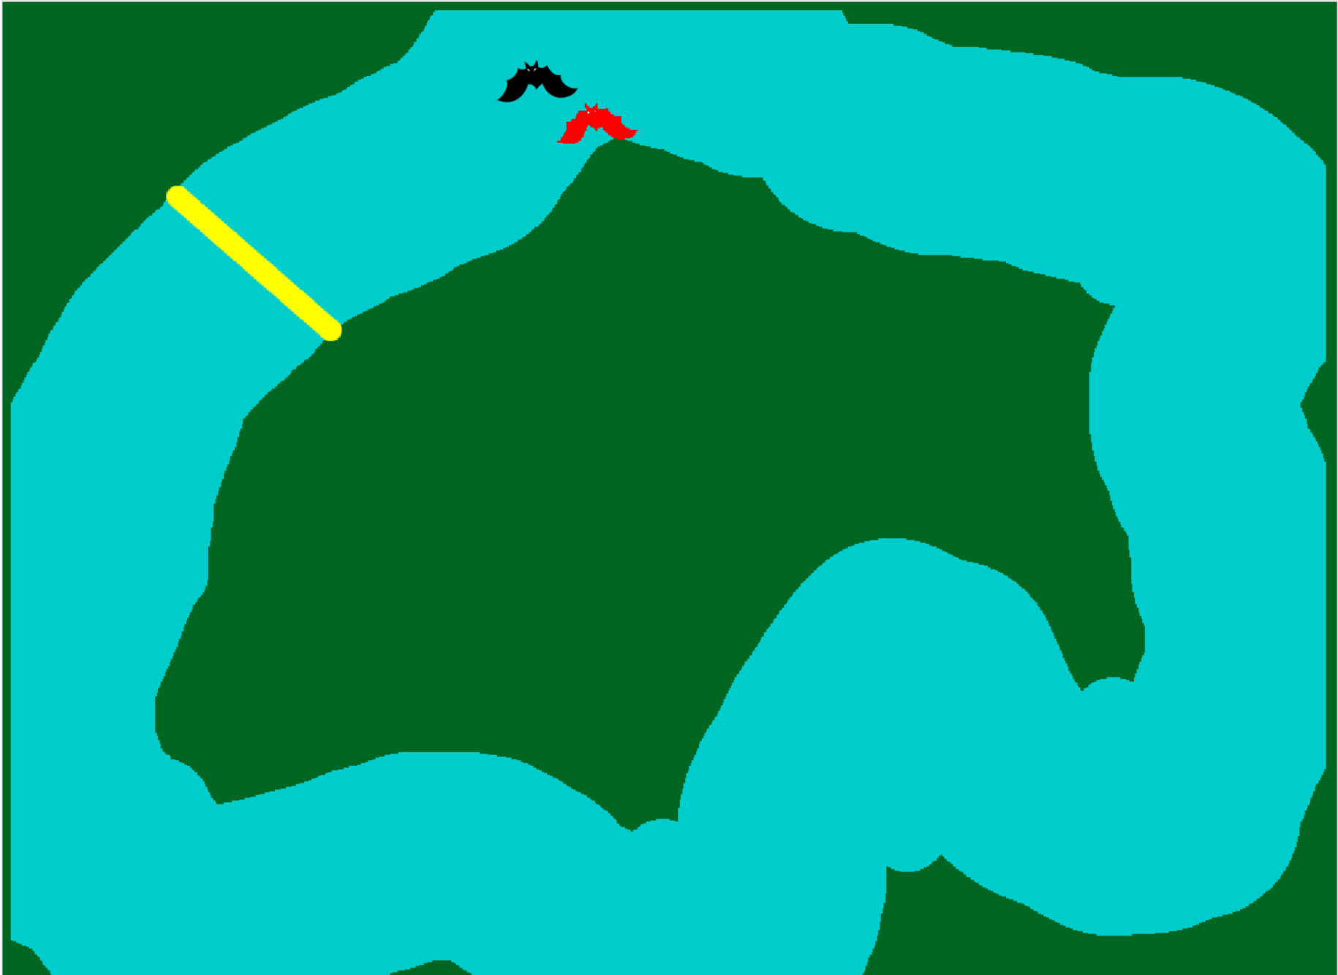

**Instructions Marks**

|  |  |
| --- | --- |
| Create 2 sprites game that 2 people can play. | /1 |
| Sprite with more than 1 costume | /2 |
| Sprite that changes costume once it touches a colour. | /2 |
| Background like a race track | /1 |
| Sprite says something once it is touches the finish line | /2 |
| Same starting location | /2 |
| Game Ends | /1 |
| Total | /11 |

To create this game:

First **create a new background**, and **paint the race track one colour**, and **the rest another colour.**

Then, **paint the finish line a third colour**

**Create two sprites**, *each* with the following instructions:

* When the green flag is clicked
  + Go to a starting point
  + Point in a starting direction
  + Loop until it touches the finish line
    - Move and change costume
    - If touching colour of the edge
      * Change to a death costume
      * Pause for some time
      * Go back to starting point
      * Point at starting direction
    - If touching the finish line colour
      * Say that it wins
* When pressing a key (ie. left arrow key)
  + Turn 5 degrees left
* When pressing another key (ie. right arrow key)
  + Turn 5 degrees right

Make sure that the keys for 1 bat is different from another bat!!!!